Báo Cáo

Lập trình di động

App:Weather App

1. Thêm Module:

ở mục Gradle Cripts -> build.gradle( Module:app)

ta thêm module gson và Picasso.

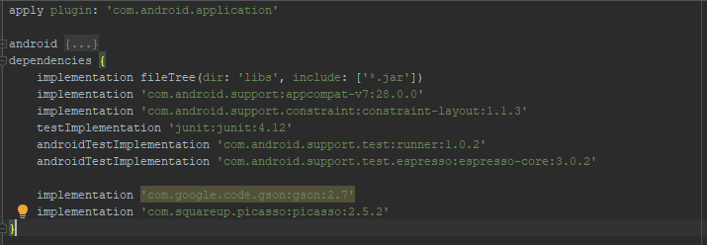

1. Activity.xml

<?xml version="1.0" encoding="utf-8"?>  
<LinearLayout xmlns:android="http://schemas.android.com/apk/res/android"  
 xmlns:app="http://schemas.android.com/apk/res-auto"  
 xmlns:tools="http://schemas.android.com/tools"  
 android:layout_width="match_parent"  
 android:layout_height="match_parent"  
 android:orientation="vertical"  
 tools:context=".MainActivity">  
  
 <TextView  
 android:id="@+id/txtCity"  
 android:layout_width="match_parent"  
 android:layout_height="wrap_content"  
 android:text=""  
 android:textStyle="bold"  
 android:textSize="36sp"  
 android:gravity="center" />  
  
 <TextView  
 android:id="@+id/txtLastUpdate"  
 android:layout_width="wrap_content"  
 android:layout_height="wrap_content"  
 android:text=""  
 android:textStyle="bold"  
 android:textSize="18sp"  
 android:gravity="center" />  
   
 <ImageView  
 android:layout_width="100dp"  
 android:layout_height="100dp"  
 android:id="@+id/imageView"  
 android:layout_gravity="center"/>  
  
 <TextView  
 android:id="@+id/txtDescription"  
 android:layout_width="match_parent"  
 android:layout_height="wrap_content"  
 android:text=""  
 android:textStyle="bold"  
 android:textSize="30sp"  
 android:gravity="center" />  
  
 <TextView  
 android:id="@+id/txtHunidity"  
 android:layout_width="match_parent"  
 android:layout_height="wrap_content"  
 android:text=""  
 android:textStyle="bold"  
 android:textSize="30sp"  
 android:gravity="center" />  
  
 <TextView  
 android:id="@+id/txtTime"  
 android:layout_width="match_parent"  
 android:layout_height="wrap_content"  
 android:text=""  
 android:textStyle="bold"  
 android:textSize="30sp"  
 android:gravity="center" />  
  
 <TextView  
 android:id="@+id/txtCelsius"  
 android:layout_width="match_parent"  
 android:layout_height="wrap_content"  
 android:text=""  
 android:textStyle="bold"  
 android:textSize="30sp"  
 android:gravity="center" />  
</LinearLayout>

1. Common code

Ở java ->com.example.doanandorid tạo packet Common và class Common.java

* 1. Common.java

package com.example.doanandroid.Common;  
  
import java.text.DateFormat;  
import java.text.SimpleDateFormat;  
import java.util.Date;  
  
public class Common {  
 public static String *API_KEY*="b63c071b32c4c4448c80735b56605b97";  
 public static String *API_LINK*="https://api.openweathermap.org/data/2.5/weather";  
  
 public static String apiRequest(String lat, String lng){  
 StringBuilder sb =new StringBuilder(*API_LINK*);  
 sb.append(String.*format*("?lat=%s&lon=%s&APPID=%s&units-metric",lat,lng,*API_KEY*));  
 return sb.toString();  
 }  
  
 public static String unixTimeStaptoDataTime(double unixTimeStamp) {  
 DateFormat dateFormat = new SimpleDateFormat("HH:mm");  
 Date date =new Date();  
 date.setTime((long)unixTimeStamp*100);  
 return dateFormat.format(date);  
  
 }  
  
 public static String getImage(String icon){  
 return String.*format*("http://openwathermap.org/img/w/%s.png",icon);  
  
 }  
 public static String GetDateNow(){  
 DateFormat dateFormat = new SimpleDateFormat("dd MMMM yyyy HH:mm");  
 Date date = new Date();  
 return dateFormat.format(date);  
 }  
  
}

* 1. Nguồn API (API_KEY, API_LINK)

Nguồn : <https://openweathermap.org/api> .

* + 1. API_LINK

Tạo tài khoản-> chọn Current weather data-> API doc

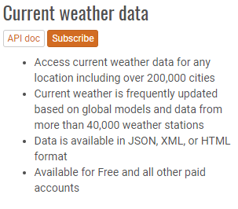

Sau khi tìm thấy thì ta tìm đến mục by geographic coordinater

Ta thấy được cách gọi API ta nhấp vào link: [api.openweathermap.org/data/2.5/weather?lat=35&lon=139](http://samples.openweathermap.org/data/2.5/weather?lat=35&lon=139&appid=b6907d289e10d714a6e88b30761fae22)

của mục examples of API calls.

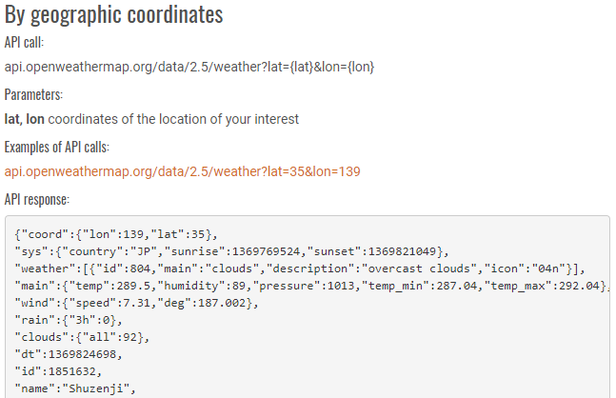

* + 1. API_KEY

Trên nav ta chọn API và chọn tiếp API key

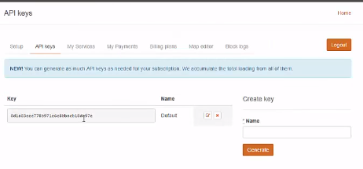

Ta copy key và paste lại trên http của link [api.openweathermap.org/data/2.5/weather?lat=35&lon=139](http://samples.openweathermap.org/data/2.5/weather?lat=35&lon=139&appid=b6907d289e10d714a6e88b30761fae22) và enter.

Đây là mã API_KEY của tôi: b63c071b32c4c4448c80735b56605b97

Ta sẽ được :



Json data:

{"coord":{"lon":139.01,"lat":35.02},"weather":[{"id":800,"main":"Clear","description":"clear sky","icon":"01n"}],"base":"stations","main":{"temp":285.514,"pressure":1013.75,"humidity":100,"temp_min":285.514,"temp_max":285.514,"sea_level":1023.22,"grnd_level":1013.75},"wind":{"speed":5.52,"deg":311},"clouds":{"all":0},"dt":1485792967,"sys":{"message":0.0025,"country":"JP","sunrise":1485726240,"sunset":1485763863},"id":1907296,"name":"Tawarano","cod":200}

Vì đây là dữ liệu mẫu còn muốn dữ liệu thật thì ta phải trả phí cho API_KEY trong openWeather.org.

* + 1. Gson data

Ta sử dụng gson edit online ta cho phần json data vào ta được

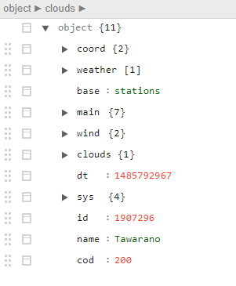

4.Model

Tạo cấu trúc model giống với json

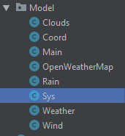

* + 1. Clouds

package com.example.doanandroid.Model;  
  
public class Clouds {  
 private int all;  
 public Clouds(int all){  
 this.all=all;  
 }  
  
 public int getAll() {  
 return all;  
 }  
  
 public void setAll(int all) {  
 this.all = all;  
 }  
}

* + 1. Cloord

package com.example.doanandroid.Model;  
  
public class Coord {  
 private double lat;  
 private double lon;  
  
 public Coord(double lat ,double lon){  
 this.lat =lat;  
 this.lon =lon;  
 }  
 public void setLat(double lat){  
 this.lat = lat;  
 }  
  
 public double getLon() {  
 return lon;  
 }  
  
 public void setLon(double lon) {  
 this.lon = lon;  
 }  
}

* + 1. Main

package com.example.doanandroid.Model;  
  
public class Main {  
 private double temp;  
 private double pressure;  
 private int humidity;  
 private double temp_min;  
 private double temp_max;  
  
 public Main(double temp,double pressure,int humidity, double temp_min,double temp_max){  
 this.temp =temp;  
 this.pressure =pressure;  
 this.humidity=humidity;  
 this.temp_min=temp_min;  
 this.temp_max=temp_max;  
 }  
  
 public double getTemp() {  
 return temp;  
 }  
  
 public void setTemp(double temp) {  
 this.temp = temp;  
 }  
  
 public double getPressure() {  
 return pressure;  
 }  
  
 public void setPressure(double pressure) {  
 this.pressure = pressure;  
 }  
  
 public int getHumidity() {  
 return humidity;  
 }  
  
 public void setHumidity(int humidity) {  
 this.humidity = humidity;  
 }  
  
 public double getTemp_min() {  
 return temp_min;  
 }  
  
 public void setTemp_min(double temp_min) {  
 this.temp_min = temp_min;  
 }  
  
 public double getTemp_max() {  
 return temp_max;  
 }  
  
 public void setTemp_max(double temp_max) {  
 this.temp_max = temp_max;  
 }  
}

* + 1. OpenWeatherMap

package com.example.doanandroid.Model;  
  
import java.util.List;  
  
public class OpenWeatherMap {  
 private Coord coord;  
 private List<Weather> weather;  
 private String base;  
 private Main main;  
 private Wind wind;  
 private Rain rain;  
 private Clouds clouds;  
 private int dt;  
 private Sys sys;  
 private int id;  
 private String name;  
 private int cod;  
  
 public OpenWeatherMap(){  
  
 }  
 public OpenWeatherMap(Coord coord, List<Weather> weather, String base, Main main, Wind wind, Rain rain, Clouds clouds, int dt, Sys sys, int id, String name, int cod) {  
 this.coord = coord;  
 this.weather = weather;  
 this.base = base;  
 this.main = main;  
 this.wind = wind;  
 this.rain = rain;  
 this.clouds = clouds;  
 this.dt = dt;  
 this.sys = sys;  
 this.id = id;  
 this.name = name;  
 this.cod = cod;  
 }  
  
  
  
 public Coord getCoord() {  
 return coord;  
 }  
  
 public void setCoord(Coord coord) {  
 this.coord = coord;  
 }  
  
 public List<Weather> getWeather() {  
 return weather;  
 }  
  
 public void setWeather(List<Weather> weather) {  
 this.weather = weather;  
 }  
  
 public String getBase() {  
 return base;  
 }  
  
 public void setBase(String base) {  
 this.base = base;  
 }  
  
 public Main getMain() {  
 return main;  
 }  
  
 public void setMain(Main main) {  
 this.main = main;  
 }  
  
 public Wind getWind() {  
 return wind;  
 }  
  
 public void setWind(Wind wind) {  
 this.wind = wind;  
 }  
  
 public Rain getRain() {  
 return rain;  
 }  
  
 public void setRain(Rain rain) {  
 this.rain = rain;  
 }  
  
 public Clouds getClouds() {  
 return clouds;  
 }  
  
 public void setClouds(Clouds clouds) {  
 this.clouds = clouds;  
 }  
  
 public int getDt() {  
 return dt;  
 }  
  
 public void setDt(int dt) {  
 this.dt = dt;  
 }  
  
 public Sys getSys() {  
 return sys;  
 }  
  
 public void setSys(Sys sys) {  
 this.sys = sys;  
 }  
  
 public int getId() {  
 return id;  
 }  
  
 public void setId(int id) {  
 this.id = id;  
 }  
  
 public String getName() {  
 return name;  
 }  
  
 public void setName(String name) {  
 this.name = name;  
 }  
  
 public int getCod() {  
 return cod;  
 }  
  
 public void setCod(int cod) {  
 this.cod = cod;  
 }  
}

* + 1. Rain

package com.example.doanandroid.Model;  
  
public class Rain {  
}

* + 1. Sys

1. package com.example.doanandroid.Model;  
     
   public class Sys {  
    private int type;  
    private int id;  
    private double message;  
    private String country;  
    private double sunrise;  
    private double sunset;  
    public Sys(int type,int id,double message,String country,double sunrise,double sunset)  
    {  
    this.type=type;  
    this.id =id;  
    this.message=message;  
    this.country=country;  
    this.sunrise=sunrise;  
    this.sunset=sunset;  
    }  
     
    public int getType() {  
    return type;  
    }  
     
    public void setType(int type) {  
    this.type = type;  
    }  
     
    public int getId() {  
    return id;  
    }  
     
    public void setId(int id) {  
    this.id = id;  
    }  
     
    public double getMessage() {  
    return message;  
    }  
     
    public void setMessage(double message) {  
    this.message = message;  
    }  
     
    public double getSunrise() {  
    return sunrise;  
    }  
     
    public void setSunrise(double sunrise) {  
    this.sunrise = sunrise;  
    }  
     
    public double getSunset() {  
    return sunset;  
    }  
     
    public String getCountry() {  
    return country;  
    }  
     
    public void setSunset(double sunset) {  
    this.sunset = sunset;  
    }  
     
    public void setCountry(String country) {  
    this.country = country;  
    }  
   }
   * 1. Weather
2. package com.example.doanandroid.Model;  
     
   public class Weather {  
    private int id;  
    private String main;  
    private String description;  
    private String icon;  
    public Weather(int id,String main,String description,String icon){  
    this.id =id;  
    this.main =main;  
    this.description=description;  
    this.icon =icon;  
    }  
     
    public int getId() {  
    return id;  
    }  
     
    public void setId(int id) {  
    this.id = id;  
    }  
     
    public String getMain() {  
    return main;  
    }  
     
    public void setMain(String main) {  
    this.main = main;  
    }  
     
    public String getDescription() {  
    return description;  
    }  
     
    public void setDescription(String description) {  
    this.description = description;  
    }  
     
    public String getIcon() {  
    return icon;  
    }  
     
    public void setIcon(String icon) {  
    this.icon = icon;  
    }  
   }
   * 1. Wind
3. package com.example.doanandroid.Model;  
     
   public class Wind {  
    private double speed;  
    private double deg;  
     
    public Wind(double speed,double deg){  
    this.speed =speed;  
    this.deg=deg;  
    }  
     
    public double getSpeed() {  
    return speed;  
    }  
     
    public double getDeg() {  
    return deg;  
    }  
     
    public void setDeg(double deg) {  
    this.deg = deg;  
    }  
     
    public void setSpeed(double speed) {  
    this.speed = speed;  
    }  
   }

5.Helper

Tạo packet Helper và Helper.java

Helpper.java:

package com.example.doanandroid.Helper;  
  
import java.io.BufferedReader;  
import java.io.IOException;  
import java.io.InputStreamReader;  
import java.net.HttpURLConnection;  
import java.net.MalformedURLException;  
import java.net.URL;  
  
public class Helper {  
 static String *stream* =null;  
  
 public Helper(){  
 }  
 public String getHTTPData(String urlString){  
 try{  
 URL url = new URL(urlString);  
 HttpURLConnection httpURLConnection =(HttpURLConnection)url.openConnection();  
 if(httpURLConnection.getResponseCode()==200)  
 {  
 BufferedReader r = new BufferedReader(new InputStreamReader(httpURLConnection.getInputStream()));  
 StringBuilder sb = new StringBuilder();  
 String line;  
 while((line =r.readLine())!=null)  
 sb.append(line);  
 *stream* =sb.toString();  
 httpURLConnection.disconnect();  
 }  
 }catch (MalformedURLException e){  
 e.printStackTrace();  
 }catch (IOException e){  
 e.printStackTrace();  
 }  
 return *stream*;  
 }  
}

6.MainActivity

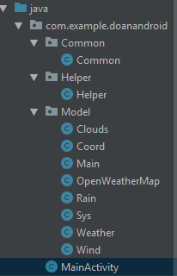

Mainactivity.java

package com.example.doanandroid;  
  
import android.Manifest;  
import android.app.ProgressDialog;  
import android.content.Context;  
import android.content.pm.PackageManager;  
import android.location.Criteria;  
import android.location.Location;  
import android.location.LocationListener;  
import android.location.LocationManager;  
import android.os.AsyncTask;  
import android.support.v4.app.ActivityCompat;  
import android.support.v7.app.AppCompatActivity;  
import android.os.Bundle;  
import android.util.Log;  
import android.widget.ImageView;  
import android.widget.TextView;  
import com.example.doanandroid.Common.Common;  
import com.example.doanandroid.Helper.Helper;  
import com.example.doanandroid.Model.OpenWeatherMap;  
import com.google.gson.Gson;  
import com.google.gson.reflect.TypeToken;  
import com.squareup.picasso.Picasso;  
  
import java.lang.reflect.Type;  
  
public class MainActivity extends AppCompatActivity implements LocationListener {  
  
 TextView txtCity, txtLastUpdate, txtDescription, txtHumidity, txtTine, txtCelsius;  
 ImageView imageView;  
  
 LocationManager locationManager;  
 String provider;  
 static double *lat*, *lng*;  
 OpenWeatherMap openWeatherMap = new OpenWeatherMap();  
  
 int MY_PERMISSION = 0;  
  
 @Override  
 protected void onCreate(Bundle savedInstanceState) {  
 super.onCreate(savedInstanceState);  
 setContentView(R.layout.*activity_main*);  
  
 //Control  
 txtCity = (TextView) findViewById(R.id.*txtCity*);  
 txtLastUpdate = (TextView) findViewById(R.id.*txtLastUpdate*);  
 txtDescription = (TextView) findViewById(R.id.*txtDescription*);  
 txtHumidity = (TextView) findViewById(R.id.*txtHunidity*);  
 txtTine = (TextView) findViewById(R.id.*txtTime*);  
 txtCelsius = (TextView) findViewById(R.id.*txtCelsius*);  
 imageView = (ImageView) findViewById(R.id.*imageView*);  
  
  
 locationManager = (LocationManager) getSystemService(Context.*LOCATION_SERVICE*);  
 provider = locationManager.getBestProvider(new Criteria(), false);  
  
 if (ActivityCompat.*checkSelfPermission*(this, Manifest.permission.*ACCESS_FINE_LOCATION*) != PackageManager.*PERMISSION_GRANTED* && ActivityCompat.*checkSelfPermission*(this, Manifest.permission.*ACCESS_COARSE_LOCATION*) != PackageManager.*PERMISSION_GRANTED*) {  
  
 ActivityCompat.*requestPermissions*(MainActivity.this, new String[]{  
 Manifest.permission.*INTERNET*,  
 Manifest.permission.*ACCESS_COARSE_LOCATION*,  
 Manifest.permission.*ACCESS_FINE_LOCATION*,  
 Manifest.permission.*ACCESS_NETWORK_STATE*,  
 Manifest.permission.*SYSTEM_ALERT_WINDOW*,  
 Manifest.permission.*WRITE_EXTERNAL_STORAGE* }, MY_PERMISSION  
 );  
 }  
 Location location = locationManager.getLastKnownLocation(provider);  
 if (location == null)  
 Log.*e*("TAG", "No Location");  
 }  
  
 @Override  
 protected void onPause() {  
 super.onPause();  
 if (ActivityCompat.*checkSelfPermission*(this, Manifest.permission.*ACCESS_FINE_LOCATION*) != PackageManager.*PERMISSION_GRANTED* && ActivityCompat.*checkSelfPermission*(this, Manifest.permission.*ACCESS_COARSE_LOCATION*) != PackageManager.*PERMISSION_GRANTED*) {  
 ActivityCompat.*requestPermissions*(MainActivity.this, new String[]{  
 Manifest.permission.*INTERNET*,  
 Manifest.permission.*ACCESS_COARSE_LOCATION*,  
 Manifest.permission.*ACCESS_FINE_LOCATION*,  
 Manifest.permission.*ACCESS_NETWORK_STATE*,  
 Manifest.permission.*SYSTEM_ALERT_WINDOW*,  
 Manifest.permission.*WRITE_EXTERNAL_STORAGE* }, MY_PERMISSION  
 );  
 }  
 locationManager.removeUpdates(this);  
 }  
  
 @Override  
 protected void onResume() {  
 super.onResume();  
 if (ActivityCompat.*checkSelfPermission*(this, Manifest.permission.*ACCESS_FINE_LOCATION*) != PackageManager.*PERMISSION_GRANTED* && ActivityCompat.*checkSelfPermission*(this, Manifest.permission.*ACCESS_COARSE_LOCATION*) != PackageManager.*PERMISSION_GRANTED*) {  
 ActivityCompat.*requestPermissions*(MainActivity.this, new String[]{  
 Manifest.permission.*INTERNET*,  
 Manifest.permission.*ACCESS_COARSE_LOCATION*,  
 Manifest.permission.*ACCESS_FINE_LOCATION*,  
 Manifest.permission.*ACCESS_NETWORK_STATE*,  
 Manifest.permission.*SYSTEM_ALERT_WINDOW*,  
 Manifest.permission.*WRITE_EXTERNAL_STORAGE* }, MY_PERMISSION  
 );  
 }  
 locationManager.requestLocationUpdates(provider, 400, 1, this);  
 }  
  
 @Override  
 public void onLocationChanged(Location location) {  
 *lat* = location.getLatitude();  
 *lng* = location.getLongitude();  
  
 new GetWearther().execute(Common.*apiRequest*(String.*valueOf*(*lat*),String.*valueOf*(*lng*)));  
 }  
  
 @Override  
 public void onStatusChanged(String provider, int status, Bundle extras) {  
  
 }  
  
 @Override  
 public void onProviderEnabled(String provider) {  
  
 }  
  
 @Override  
 public void onProviderDisabled(String provider) {  
  
 }  
 private class GetWearther extends AsyncTask<String,Void,String>  
 {  
 ProgressDialog pd =new ProgressDialog(MainActivity.this);  
  
  
 @Override  
 protected void onPreExecute() {  
 super.onPreExecute();  
 pd.setTitle("Please wait...");  
 pd.show();  
 }  
  
  
 @Override  
 protected String doInBackground(String... strings) {  
 String stream = null;  
 String urlString= strings[0];  
  
 Helper http =new Helper();  
 stream =http.getHTTPData(urlString);  
 return stream;  
  
 }  
 @Override  
 protected void onPostExecute(String s) {  
 super.onPostExecute(s);  
 if (s.contains("Error: Not found city"))  
 {  
 pd.dismiss();  
 return;  
 }  
 Gson gson =new Gson();  
 Type mTyle =new TypeToken<OpenWeatherMap>(){}.getType();  
 openWeatherMap =gson.fromJson(s,mTyle);  
 pd.dismiss();  
  
 txtCity.setText(String.*format*("%s,%s",openWeatherMap.getName(),openWeatherMap.getSys().getCountry()));  
 txtLastUpdate.setText(String.*format*("LastUpdate: $s", Common.*GetDateNow*()));  
 txtDescription.setText(String.*format*("%s",openWeatherMap.getWeather().get(0).getDescription()));  
 txtHumidity.setText(String.*format*("%d%%",openWeatherMap.getMain().getHumidity()));  
 txtTine.setText(String.*format*("%s/%s",Common.*unixTimeStaptoDataTime*(openWeatherMap.getSys().getSunrise()),Common.*unixTimeStaptoDataTime*(openWeatherMap.getSys().getSunset())));  
 txtCelsius.setText(String.*format*("%.2f °C",openWeatherMap.getMain().getTemp()));  
 Picasso.*with*(MainActivity.this)  
 .load(Common.*getImage*(openWeatherMap.getWeather().get(0).getIcon()))  
 .into(imageView);  
 }  
 }  
}

7.AndroidMaifest.xml

<?xml version="1.0" encoding="utf-8"?>  
<manifest xmlns:android="http://schemas.android.com/apk/res/android"  
 package="com.example.doanandroid">  
  
 <uses-permission android:name="android.permission.ACCESS_COARSE_LOCATION" />  
 <uses-permission android:name="android.permission.ACCESS_FINE_LOCATION" />  
 <uses-permission android:name="android.permission.ACCESS_NETWORK_STATE" />  
 <uses-permission android:name="android.permission.SYSTEM_ALERT_WINDOW" />  
 <uses-permission android:name="android.permission.WRITE_EXTERNAL_STORAGE" />  
 <uses-permission android:name="android.permission.INTERNET" />  
 <uses-permission android:name="com.google.android.providers.gsf.permission.READ_GSERVICES"/>  
  
 <application  
 android:allowBackup="true"  
 android:icon="@mipmap/ic_launcher"  
 android:label="@string/app_name"  
 android:roundIcon="@mipmap/ic_launcher_round"  
 android:supportsRtl="true"  
 android:theme="@style/AppTheme">  
 <activity android:name=".MainActivity">  
 <intent-filter>  
 <action android:name="android.intent.action.MAIN" />  
  
 <category android:name="android.intent.category.LAUNCHER" />  
 </intent-filter>  
 </activity>  
 </application>  
  
</manifest>